Assignment 2

Name:

Student No.:

Date: December 9, 2016

Contents

Question 1 3

Question 2 14

Question 3 18

Executing duration expression code 28

# Question 1

* 1. The finalized query text

SELECT tt.Description, COUNT(d.DeliveryNumber) AS TotalSuccessfulDeliveries

FROM Delivery AS d INNER JOIN

DeliveryStatus AS ds ON d.StatusCode = ds.StatusCode INNER JOIN

DeliveryRoute AS dr ON dr.DeliveryNumber = d.DeliveryNumber INNER JOIN

Transport AS t ON t.TransportNumber = dr.OutboundTransportNumber INNER JOIN

TransportType AS tt ON tt.TransportTypeID = t.TransportTypeID

WHERE (ds.StatusCode = 'D') AND (d.PickupDateTime BETWEEN @startDate AND @endDate)

GROUP BY tt.Description

* 1. A snapshot of query ran successfully with it's result in SQL Server Management Studio

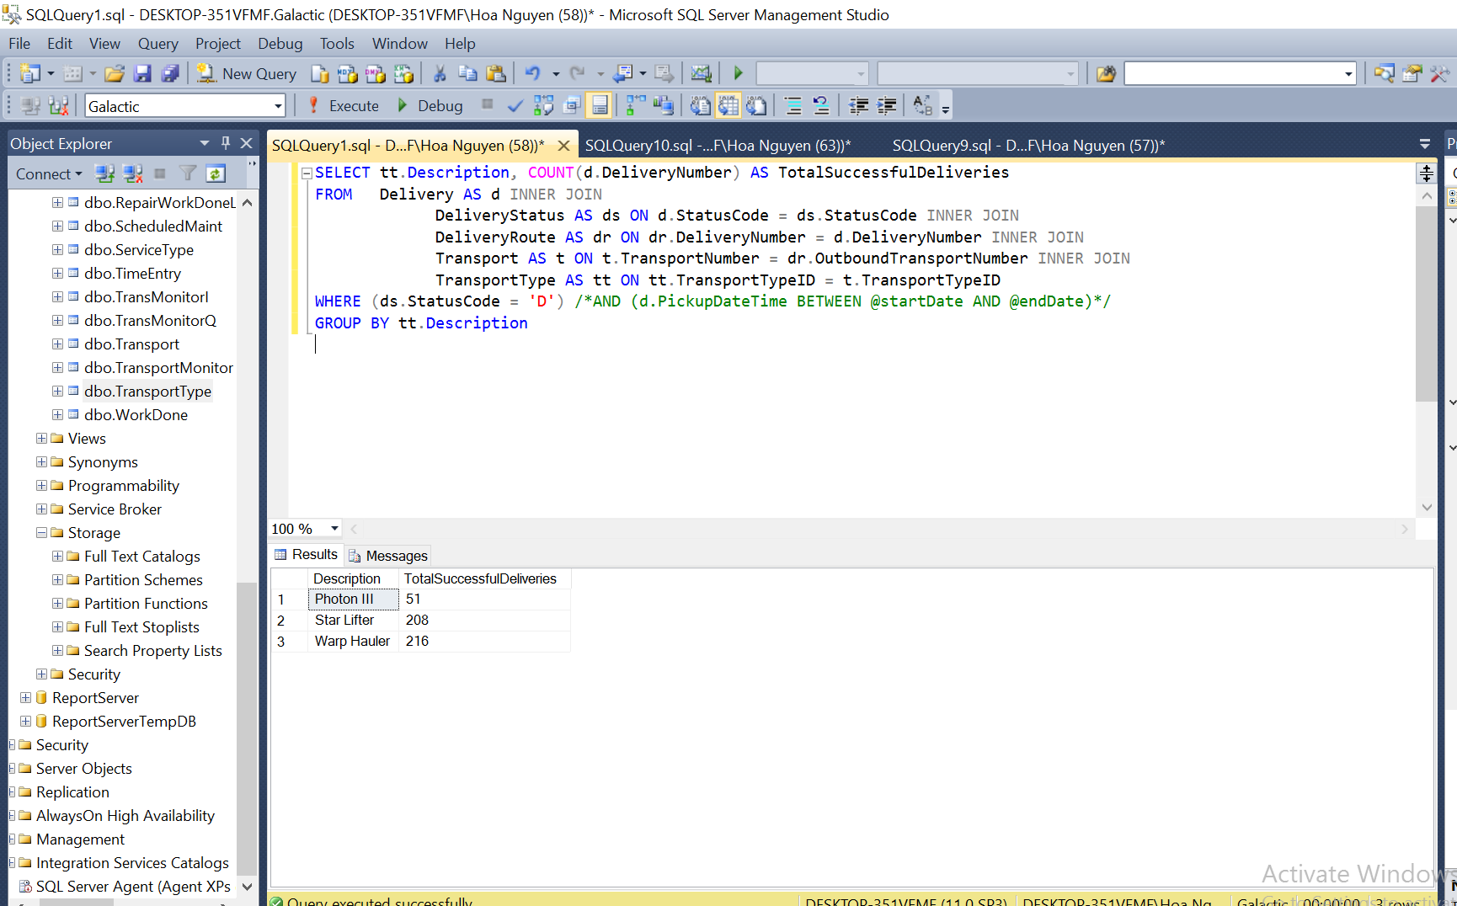

* 1. Snapshots of your report Data Sets details

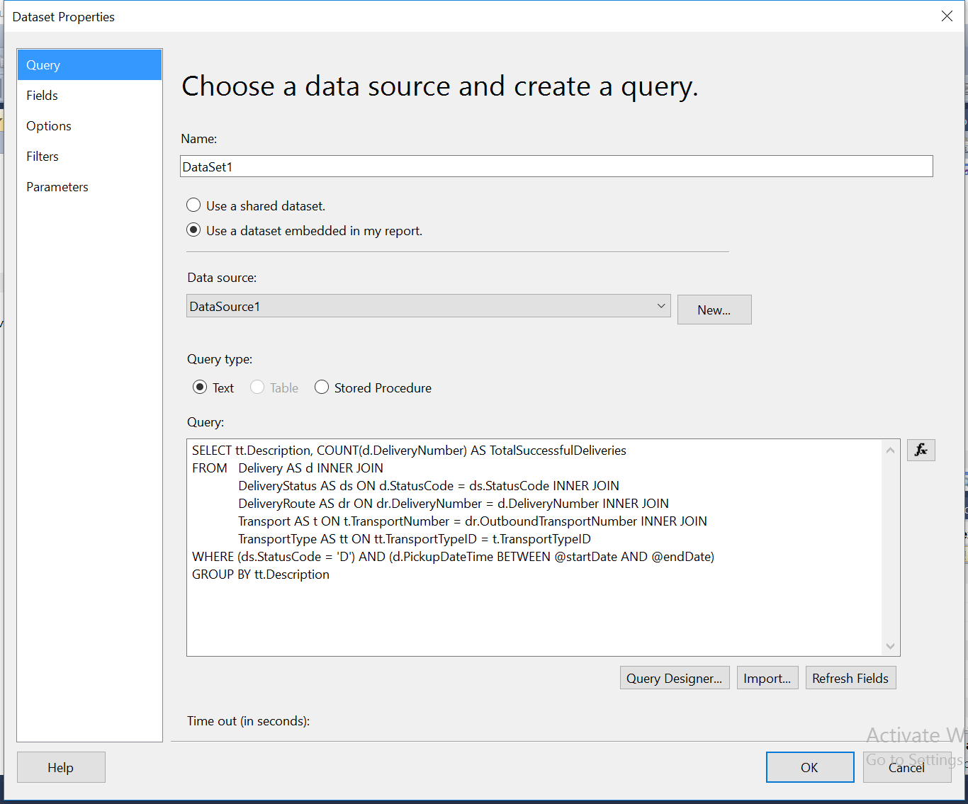

* 1. A snapshot of your report Parameter details

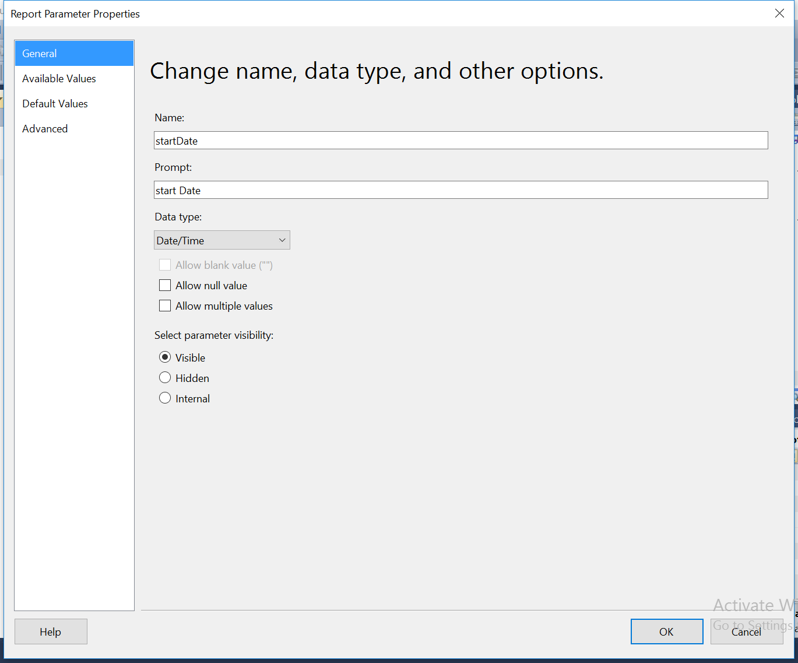



* 1. A snapshot of your report Table/Matrix/Tablix details (in design tab)

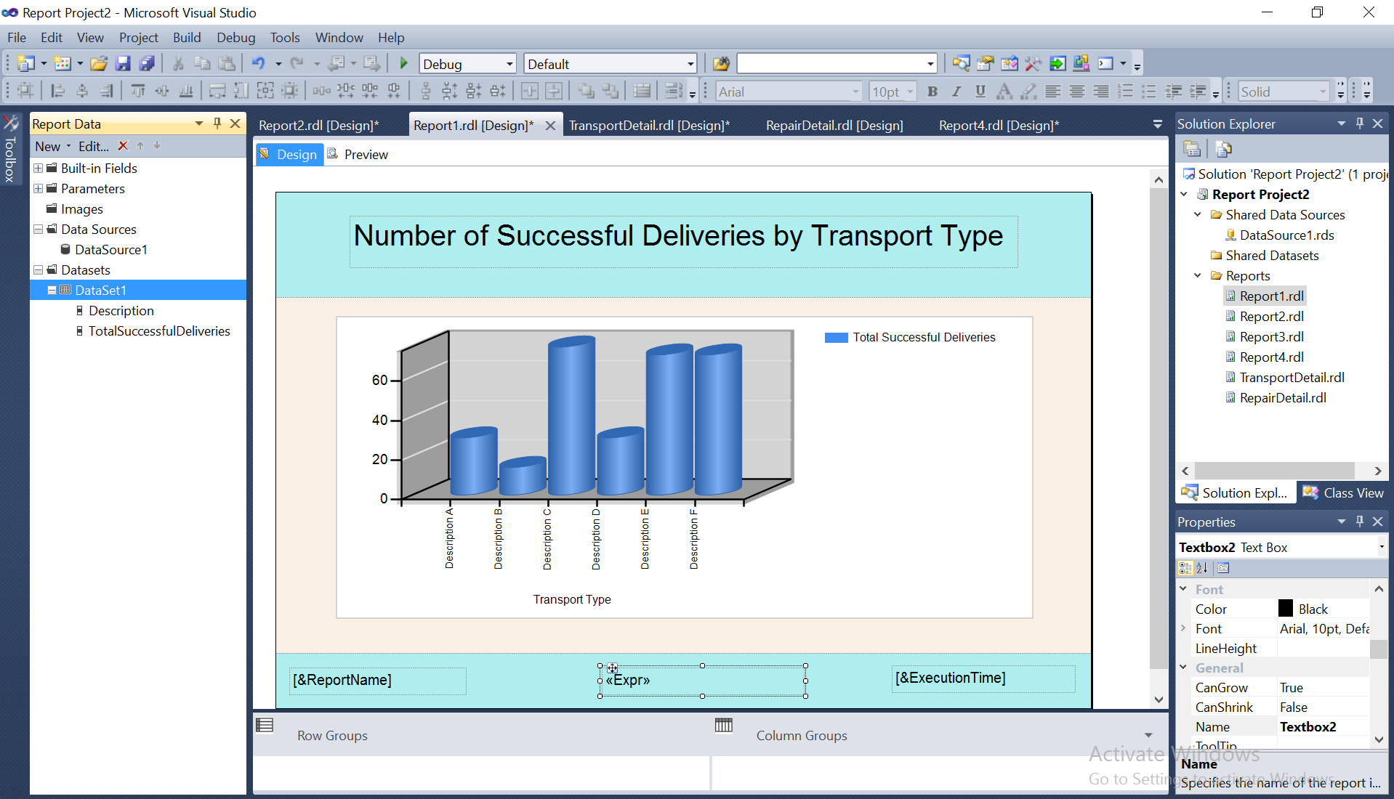

* 1. A snapshot of your report preview after completion (in preview tab) showing the desired outcome.

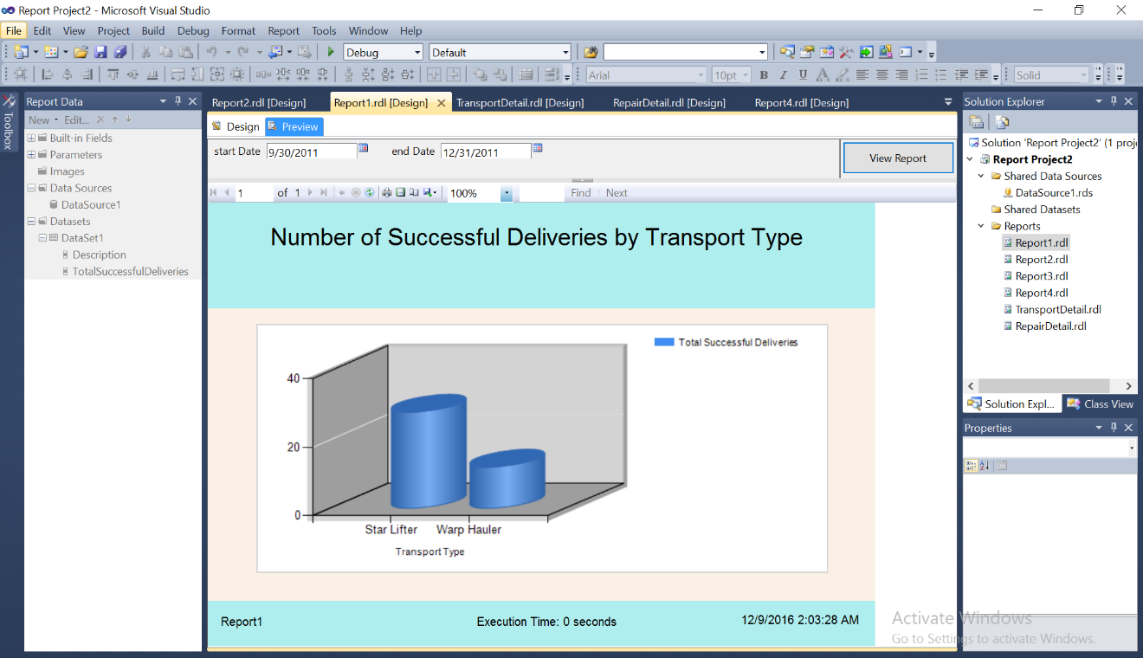

* 1. Create a child report
     1. The finalized query text

SELECT TransportTypeID, CargoCapacity, Range, PropulsionID, Cost, Crew,

Manufacturer, ManCity, ManState, ManZipCode, ManPlanetAbbrv, Description

FROM TransportType

WHERE (Description = @TTDescription)

* + 1. A snapshot of query ran successfully with it's result in SQL Server Management Studio

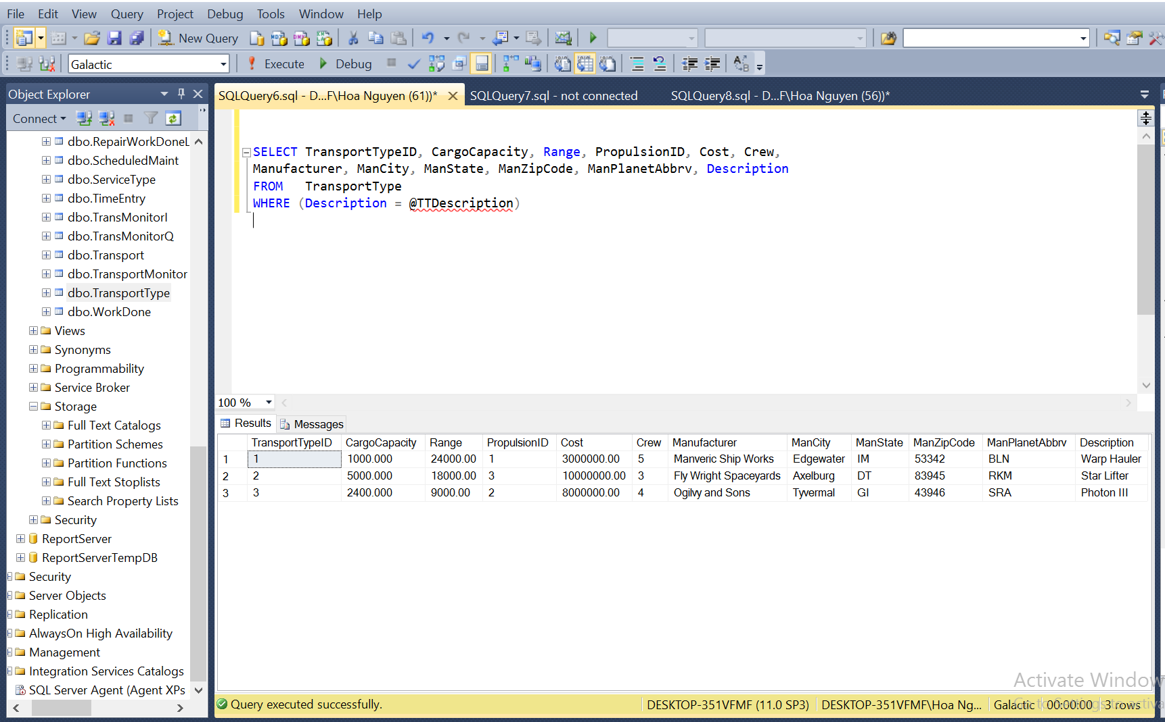

* + 1. Snapshots of your report Data Sets details

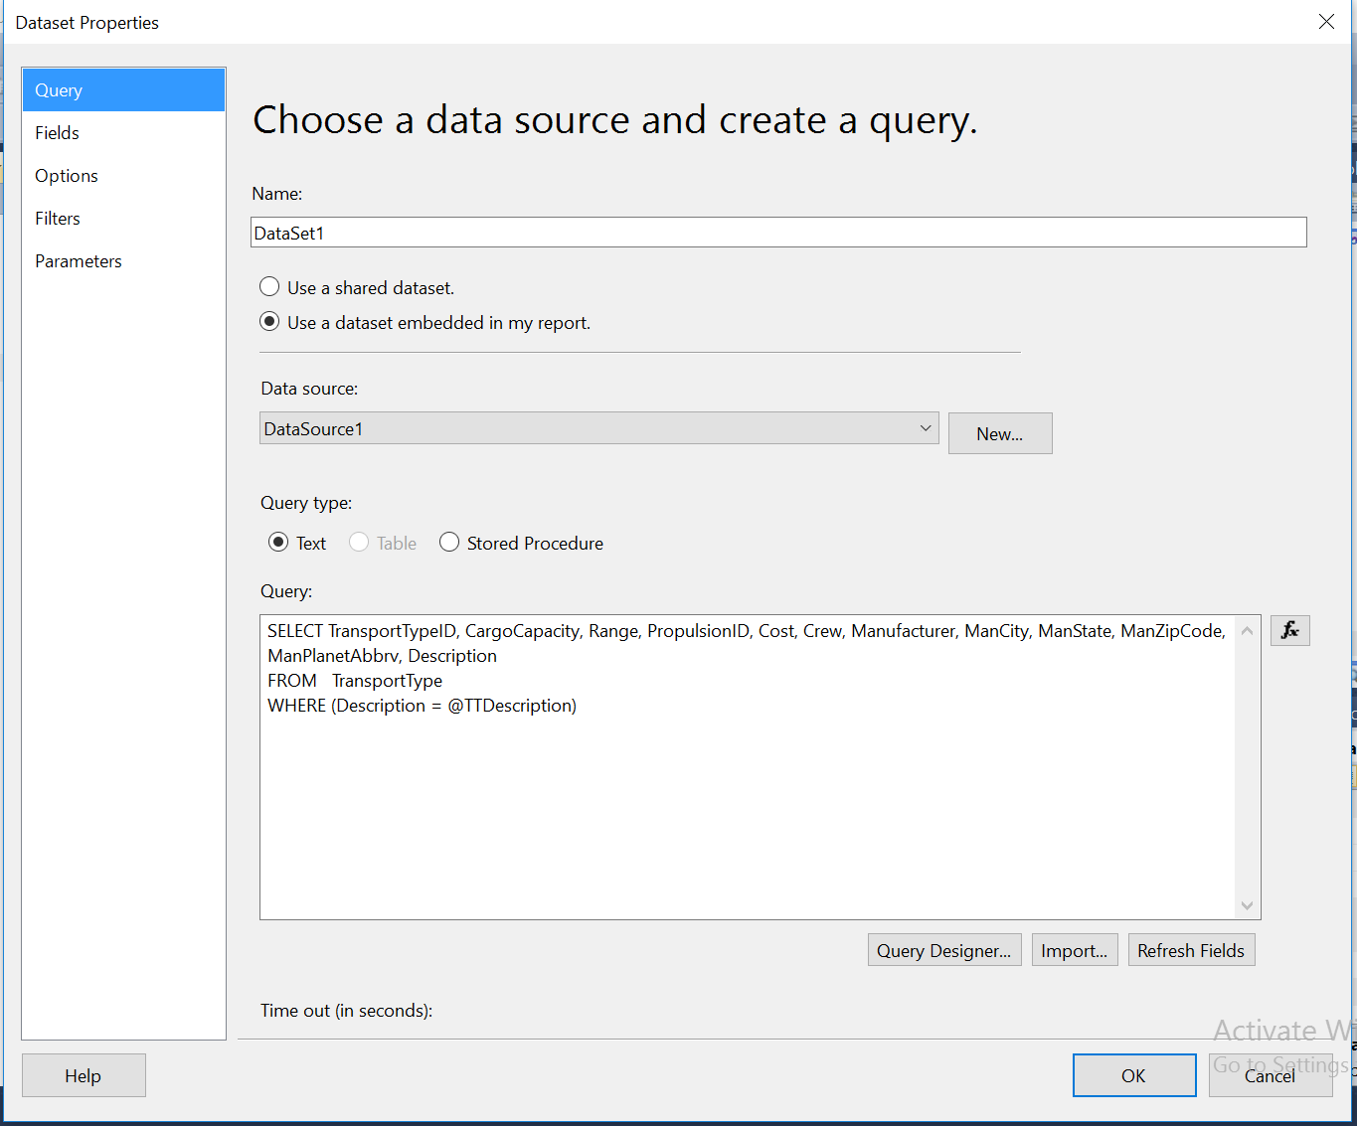

* + 1. A snapshot of your report Parameter details

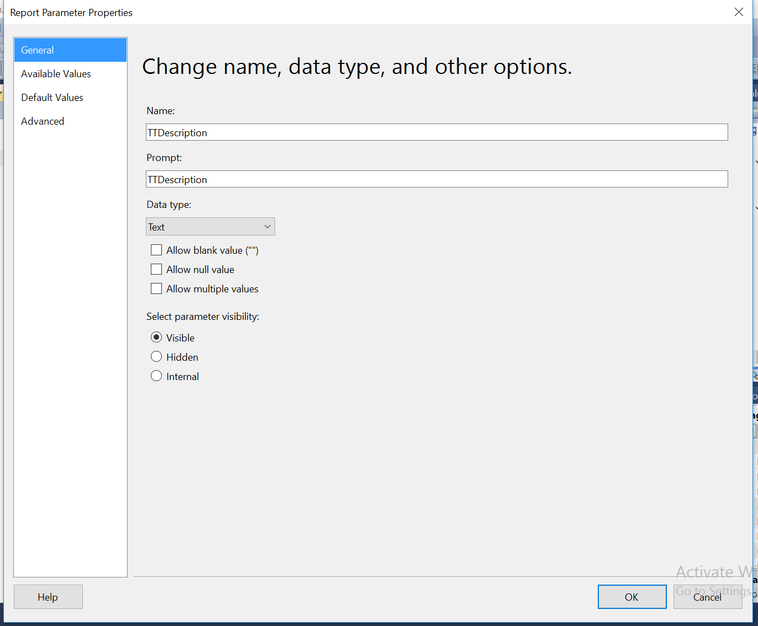

* + 1. A snapshot of your report Table/Matrix/Tablix details (in design tab)

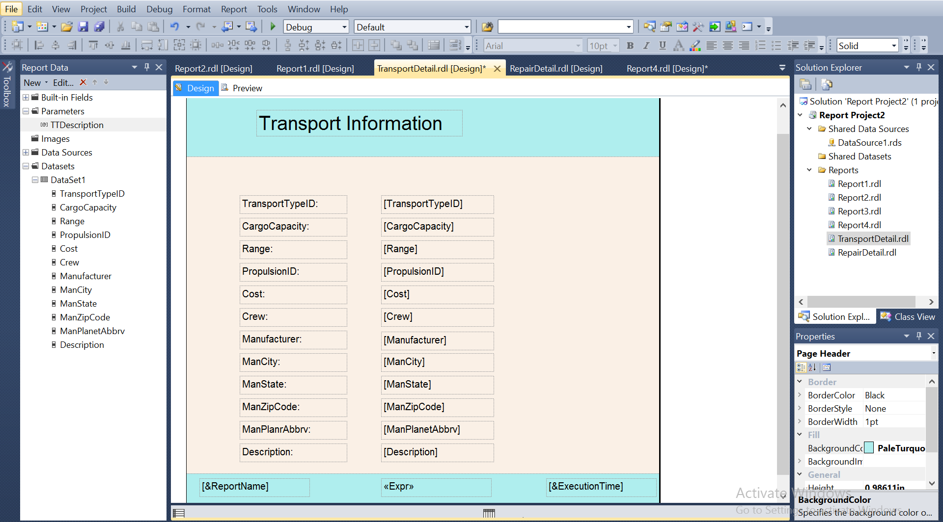

* 1. Connect to child report

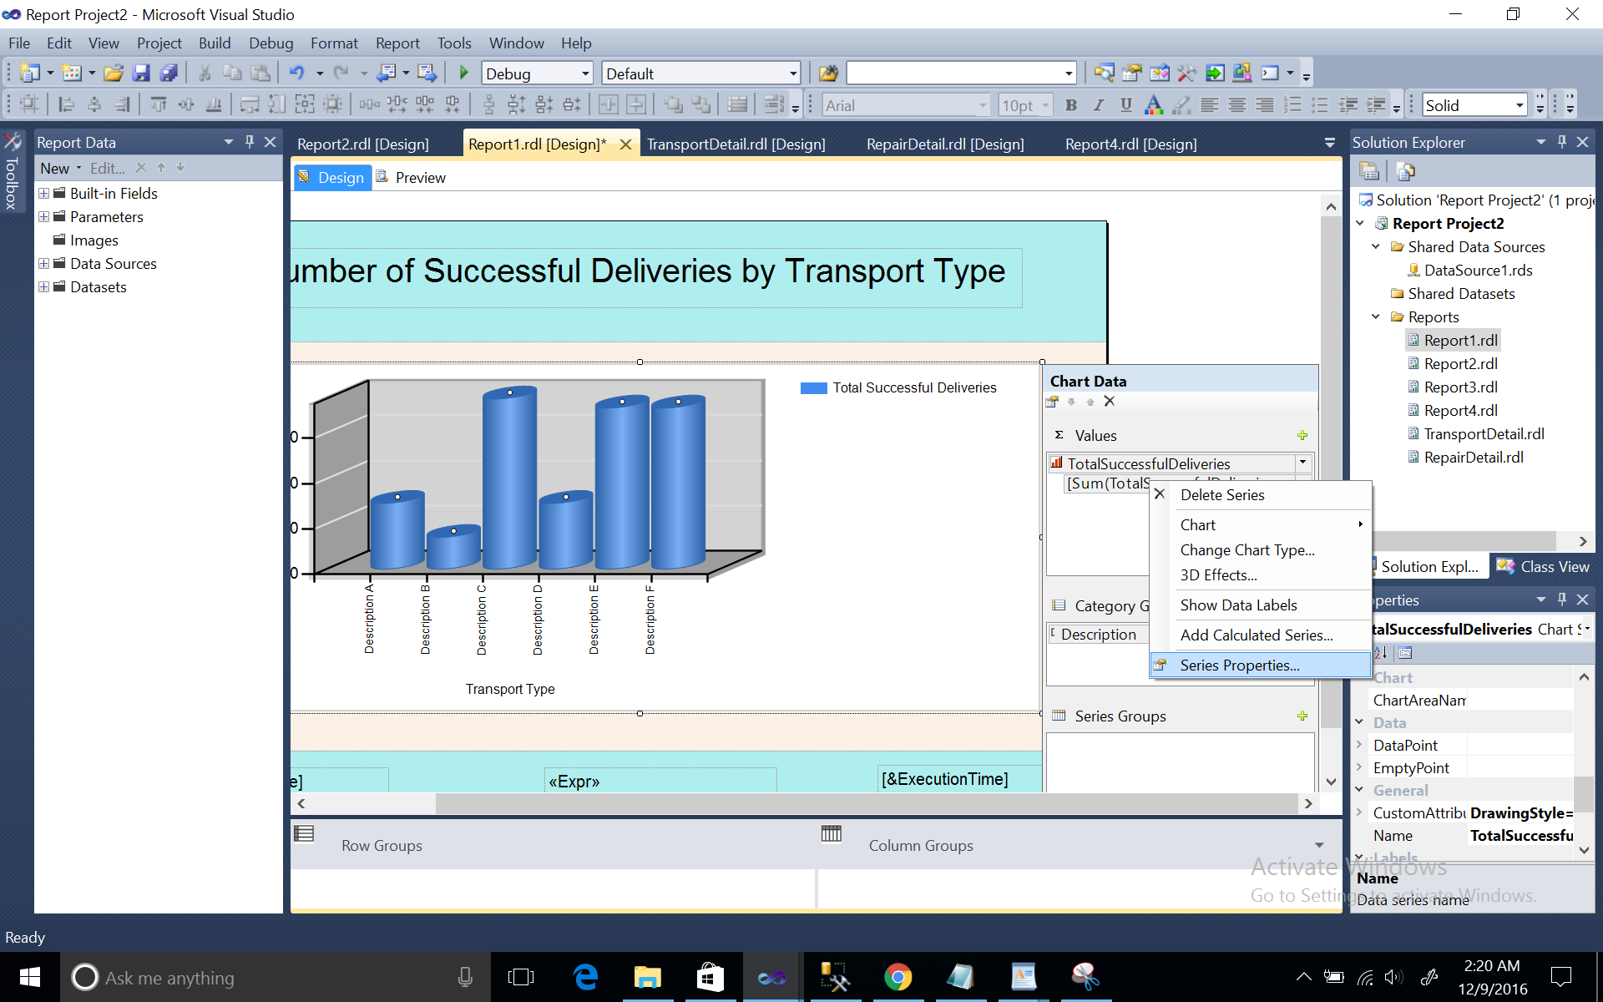

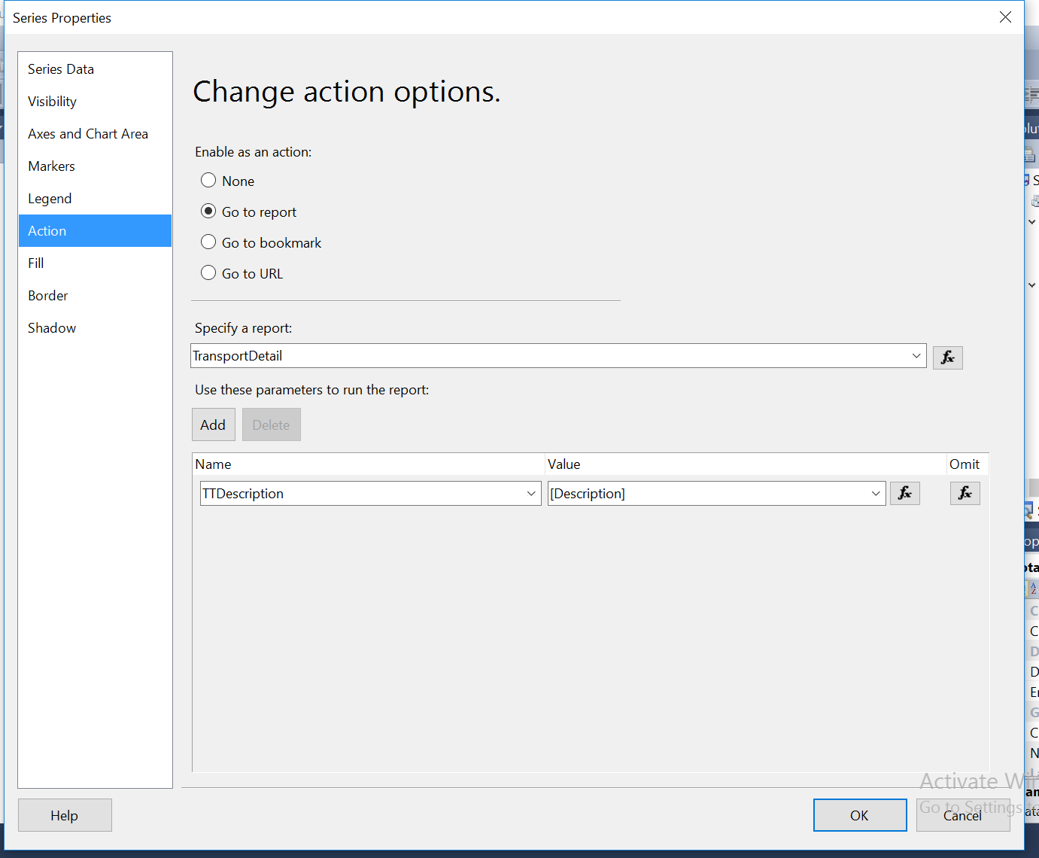

* 1. Show child report when description column is clicked.

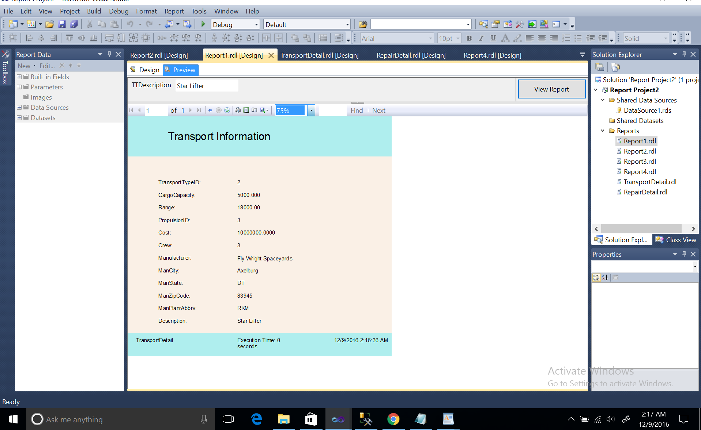

Question 2 (include extra function)

* 1. The finalized query text

SELECT st.Description AS ServiceType, c.Name AS CustomerName,

DATEPART(Year, d.DeliveryDateTime) AS DeliveryYear,

DATEPART(QUARTER, d.DeliveryDateTime) AS QuarterOfTheYear,

DATEPART(MONTH, d.DeliveryDateTime) AS MonthOfTheYear,

CASE

When DATEPART(WEEKDAY, d.DeliveryDateTime)= '1' Then 'Sunday'

When DATEPART(WEEKDAY, d.DeliveryDateTime)= '2' Then 'Monday'

When DATEPART(WEEKDAY, d.DeliveryDateTime)= '3' Then 'Tuesday'

When DATEPART(WEEKDAY, d.DeliveryDateTime)= '4' Then 'Wednesday'

When DATEPART(WEEKDAY, d.DeliveryDateTime)= '5' Then 'Thursday'

When DATEPART(WEEKDAY, d.DeliveryDateTime)= '6' Then 'Friday'

When DATEPART(WEEKDAY, d.DeliveryDateTime)= '7' Then 'Saturday'

End as DayOfTheWeek,

COUNT(d.DeliveryNumber)

AS NumberOfDeliveries

FROM Customer AS c INNER JOIN

Delivery AS d ON c.CustomerNumber = d.CustomerNumber INNER JOIN

ServiceType AS st ON st.ServiceTypeCode = d.ServiceTypeCode

GROUP BY st.Description, c.Name, DATEPART(Year, d.DeliveryDateTime),DATEPART(QUARTER, d.DeliveryDateTime),DATEPART(MONTH, d.DeliveryDateTime), DATEPART(WEEKDAY, d.DeliveryDateTime)

2.2 A snapshot of query ran successfully with it's result in SQL Server Management Studio

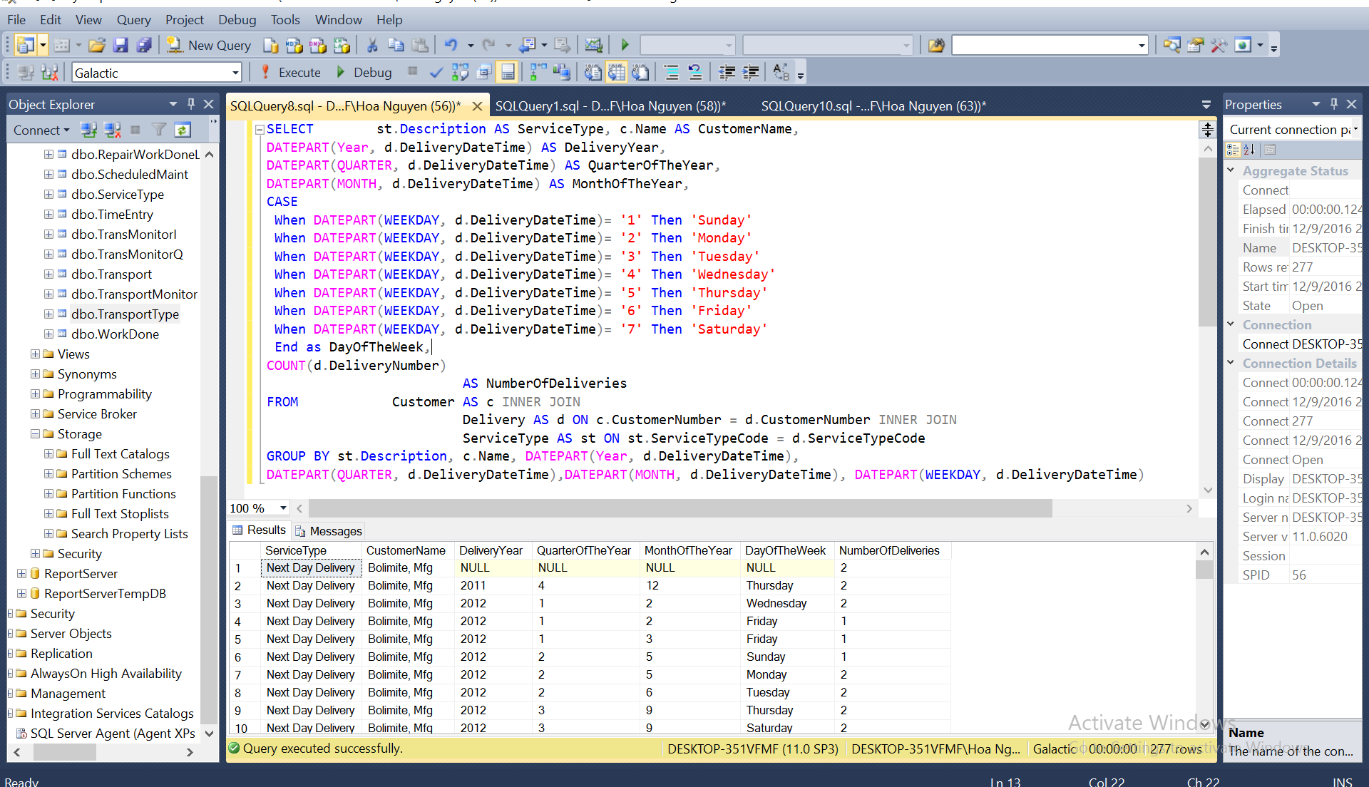

* 1. Snapshots of your report Data Sets details

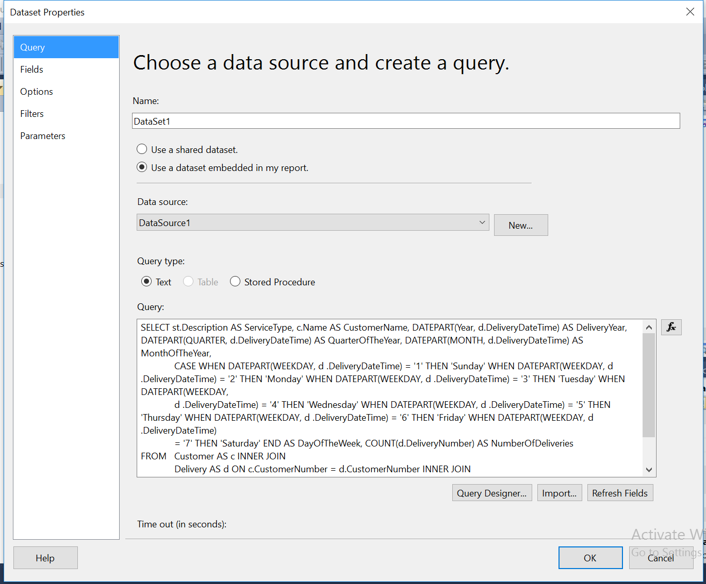

2.4 A snapshot of your report Table/Matrix/Tablix details (in design tab)

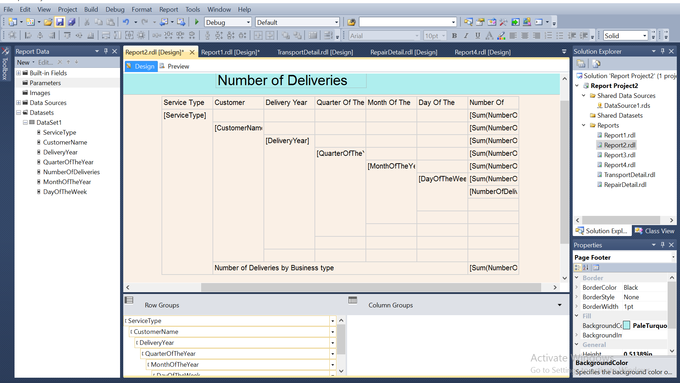

* 1. A snapshot of your report preview after completion (in preview tab) showing the desired outcome.

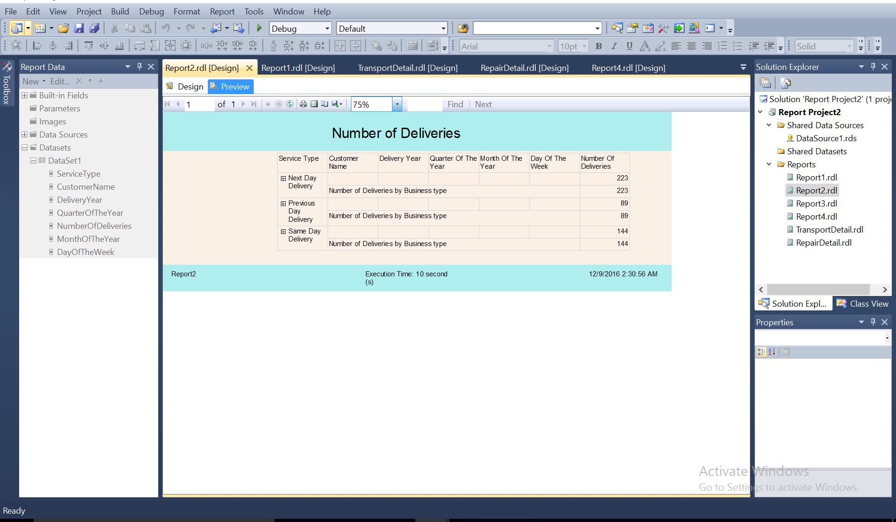

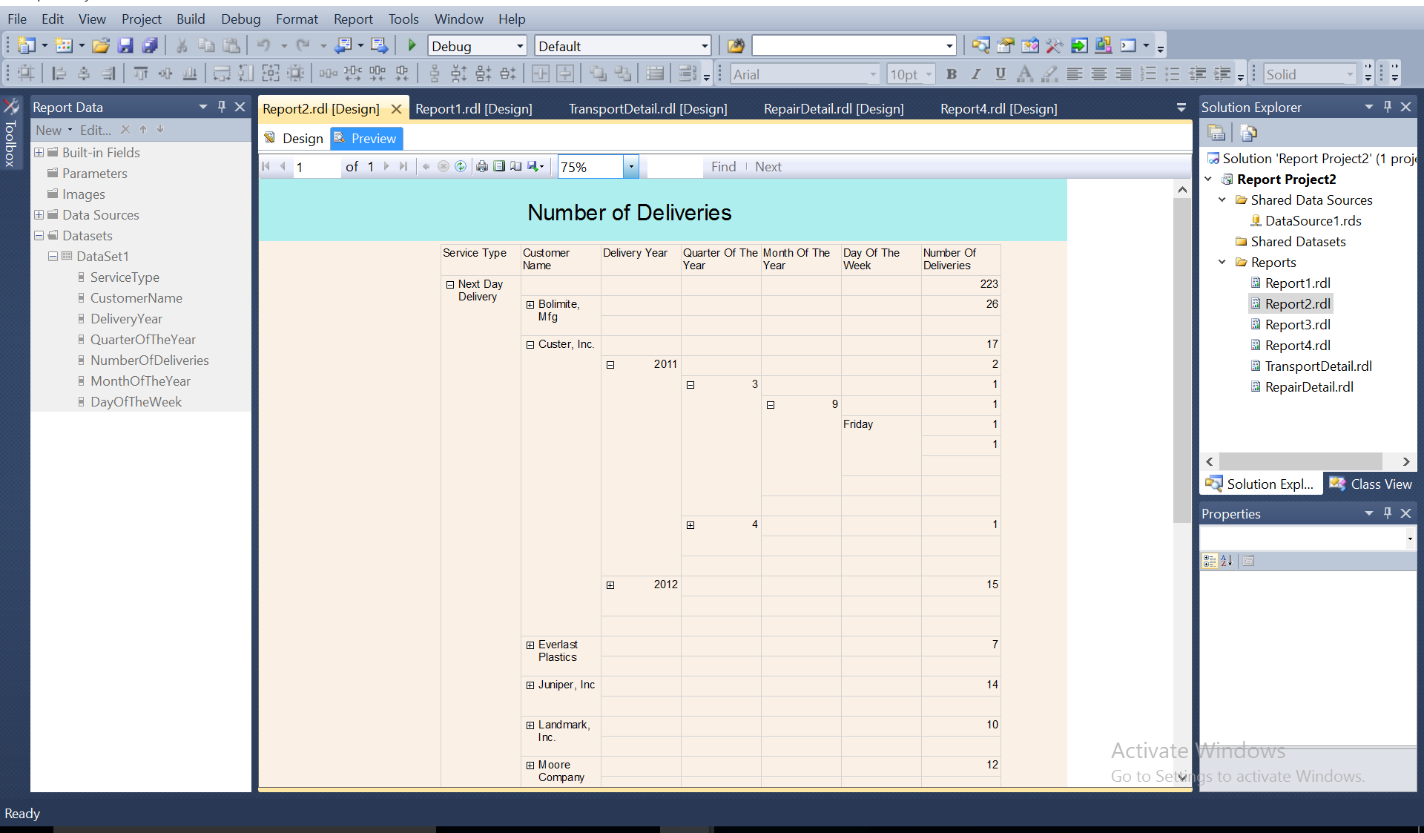

# Question 3

* 1. The finalized query text

SELECT Employee_1.EmployeeNumber, Employee_1.FirstName, Employee_1.MiddleInitial,Employee_1.LastName, Repair.RepairID, RepairCause.Description AS RepairCause

FROM Employee AS Employee_1 INNER JOIN

RepairWorkDoneLink ON Employee_1.EmployeeNumber = RepairWorkDoneLink.EmployeeNumber INNER JOIN

Repair ON RepairWorkDoneLink.RepairID = Repair.RepairID INNER JOIN

RepairCause ON Repair.CauseCode = RepairCause.CauseCode

WHERE (Employee_1.EmployeeNumber = @EmployeeNumber)

* 1. A snapshot of query ran successfully with it's result in SQL Server Management Studio

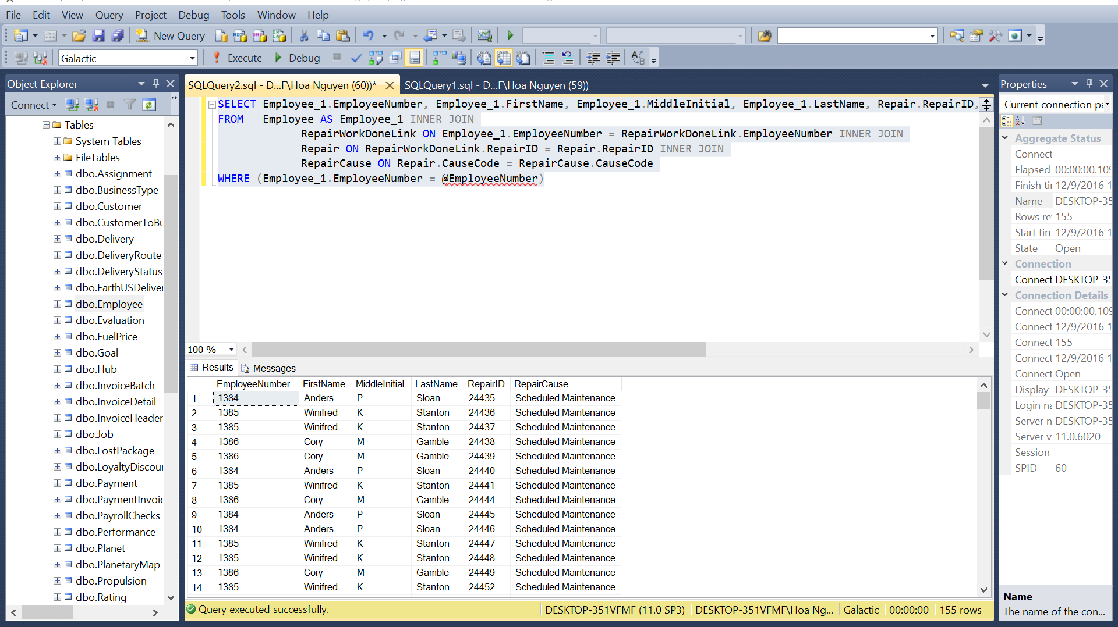

* 1. Snapshots of your report Data Sets detail

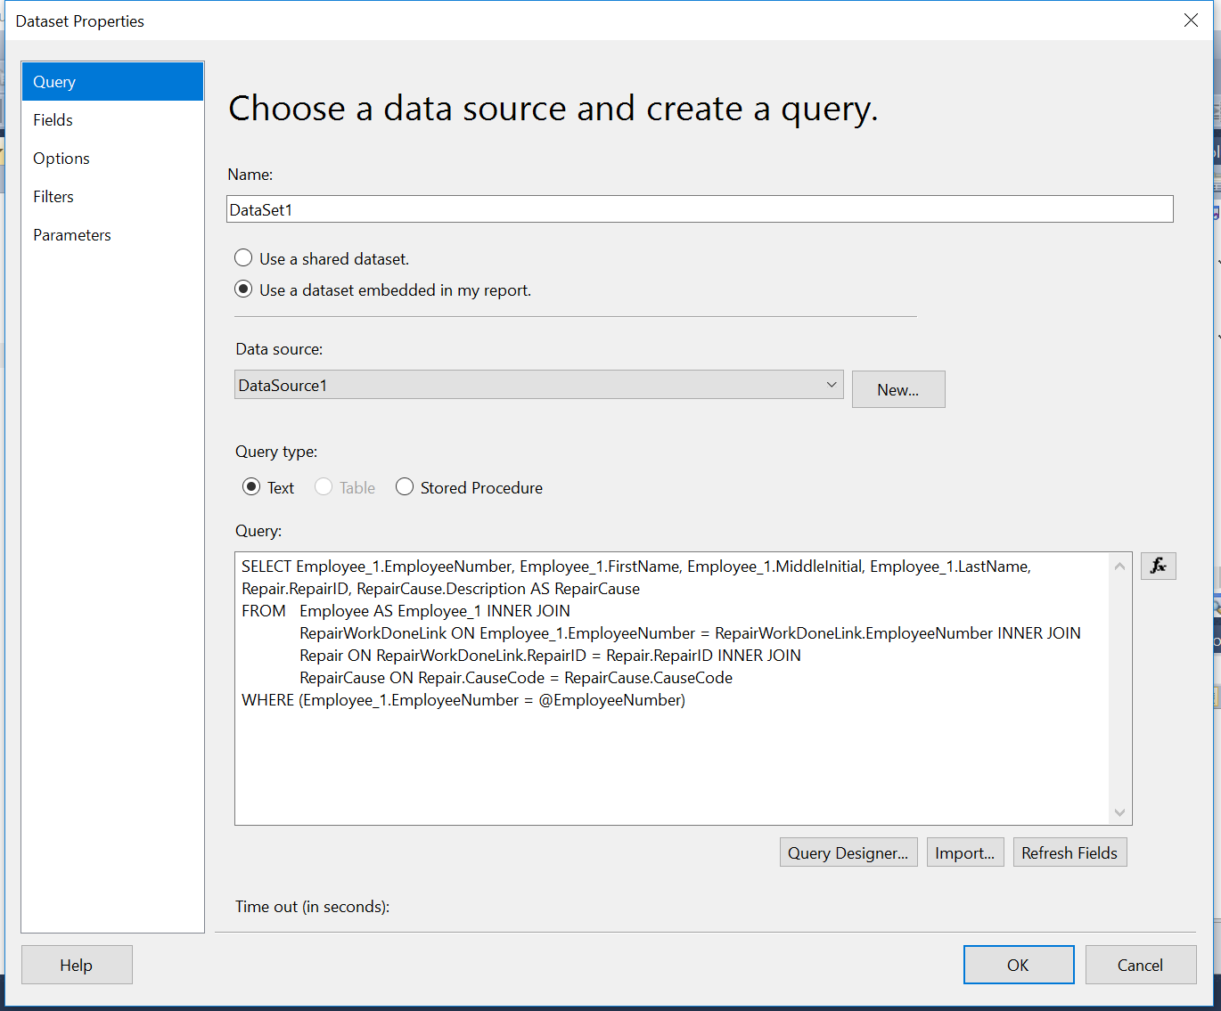

* 1. A snapshot of your report Parameter details

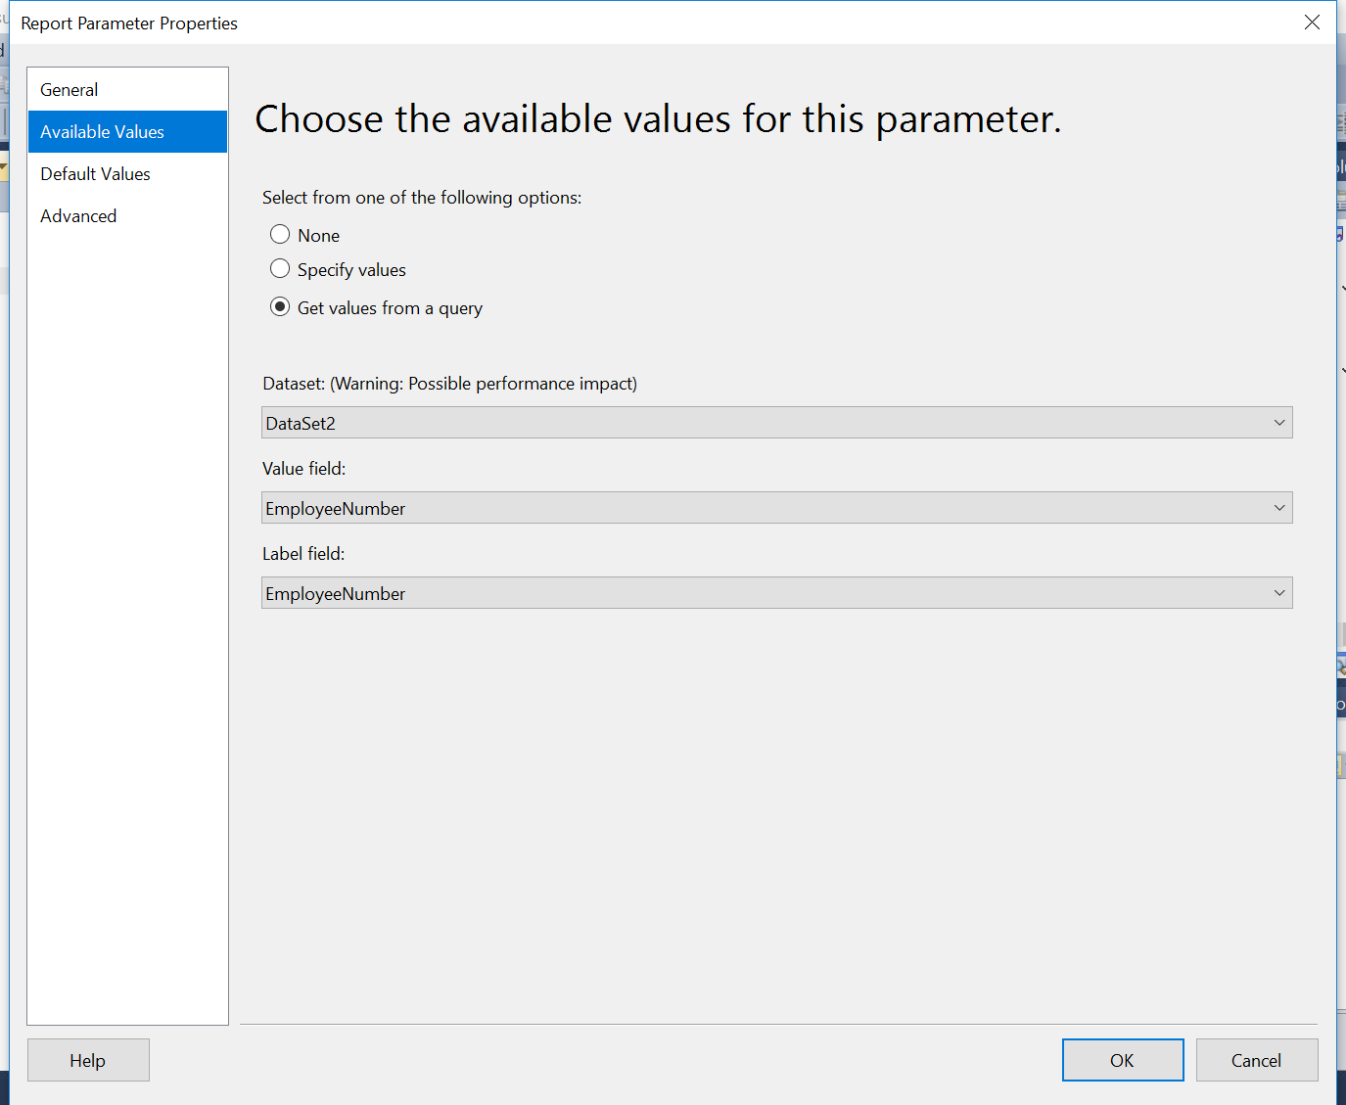

* 1. A snapshot of your report Table/Matrix/Tablix details (in design tab)

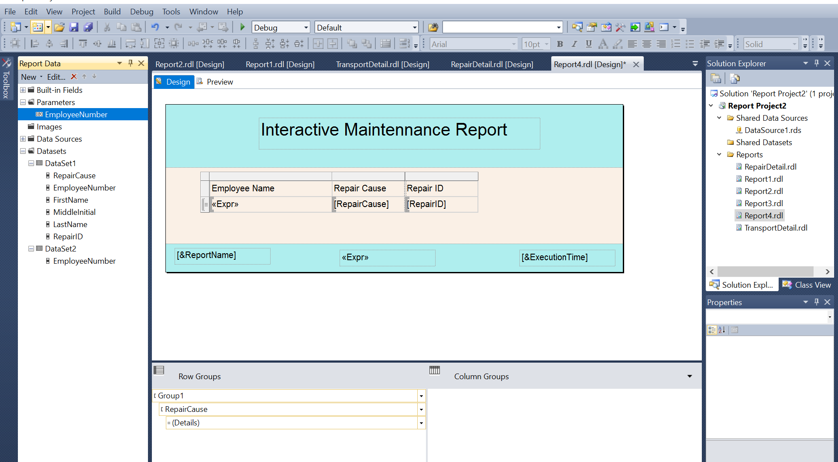

* 1. A snapshot of your report preview after completion (in preview tab) showing the desired outcome.

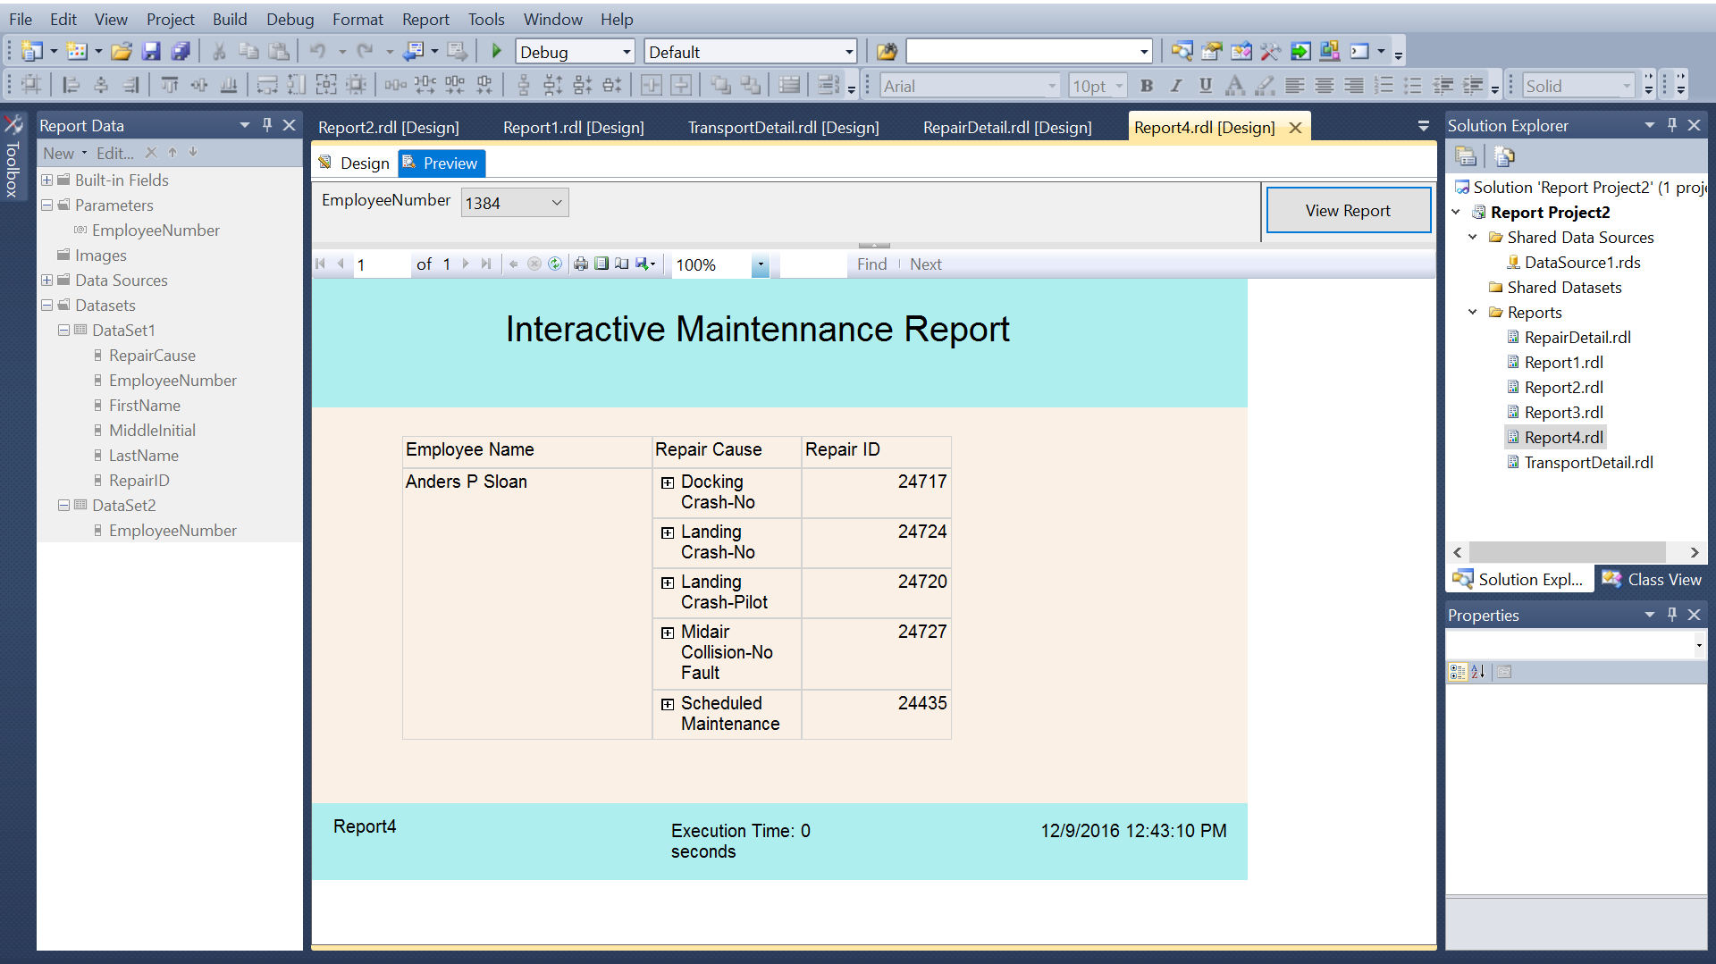

* 1. Create child report
     1. The finalized query text

SELECT Repair.TransportNumber, Repair.BeginWorkDate, RepairCause.Description AS RepairCause, Repair.RepairCost, Repair.EndWorkDate, WorkDone.Description AS WorkDone, TransportType.Description AS TransportType

FROM Repair INNER JOIN

RepairCause ON Repair.CauseCode = RepairCause.CauseCode INNER JOIN

RepairWorkDoneLink ON Repair.RepairID = RepairWorkDoneLink.RepairID INNER JOIN

WorkDone ON RepairWorkDoneLink.WorkDoneCode = WorkDone.WorkDoneCode INNER JOIN

Transport ON Repair.TransportNumber = Transport.TransportNumber INNER JOIN

TransportType ON Transport.TransportTypeID = TransportType.TransportTypeID

WHERE (Repair.RepairID = @RepairID)

* + 1. A snapshot of query ran successfully with it's result in SQL Server Management Studio

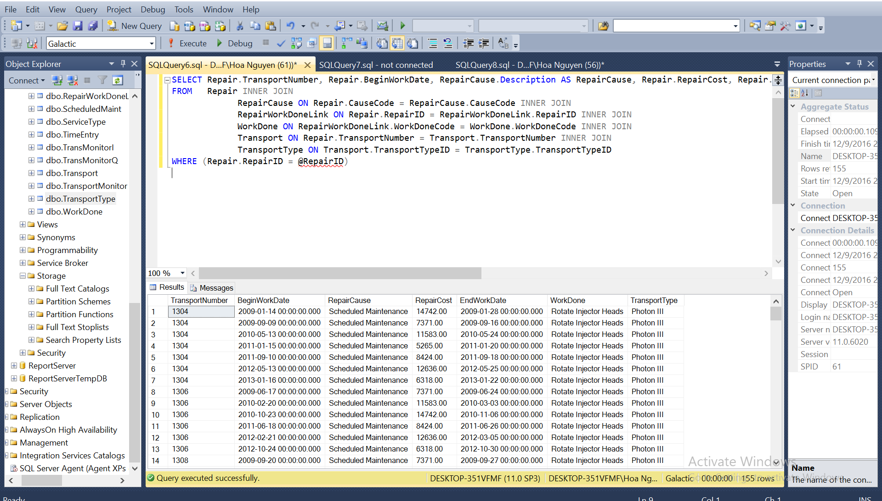

* + 1. Snapshots of your report Data Sets details

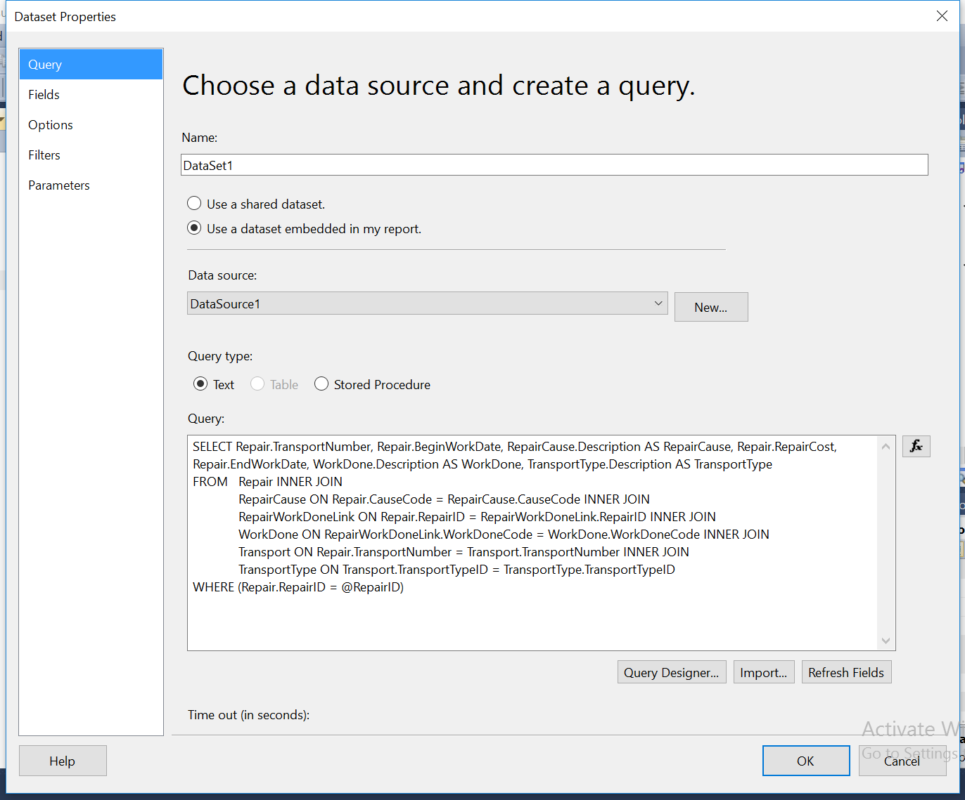

* + 1. A snapshot of your report Parameter details

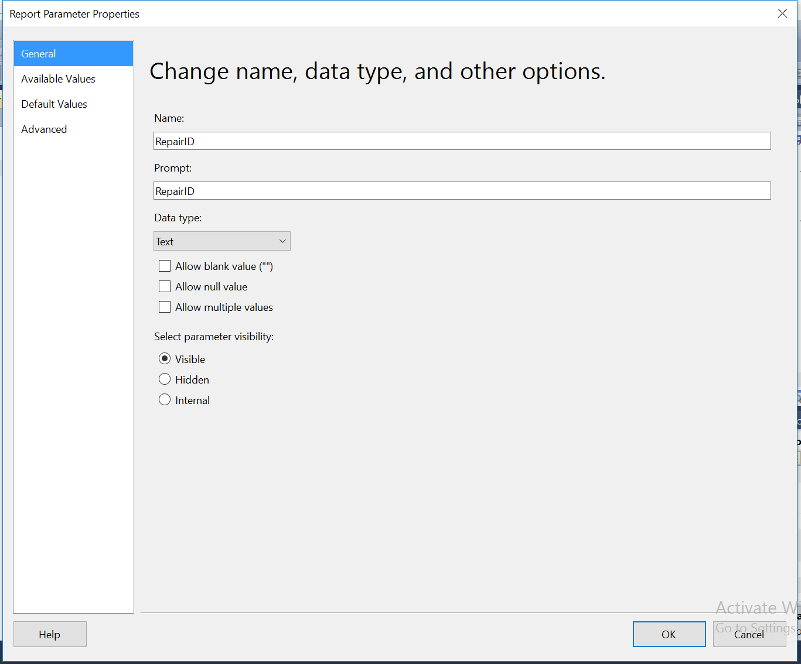

* + 1. A snapshot of your report Table/Matrix/Tablix details (in design tab)

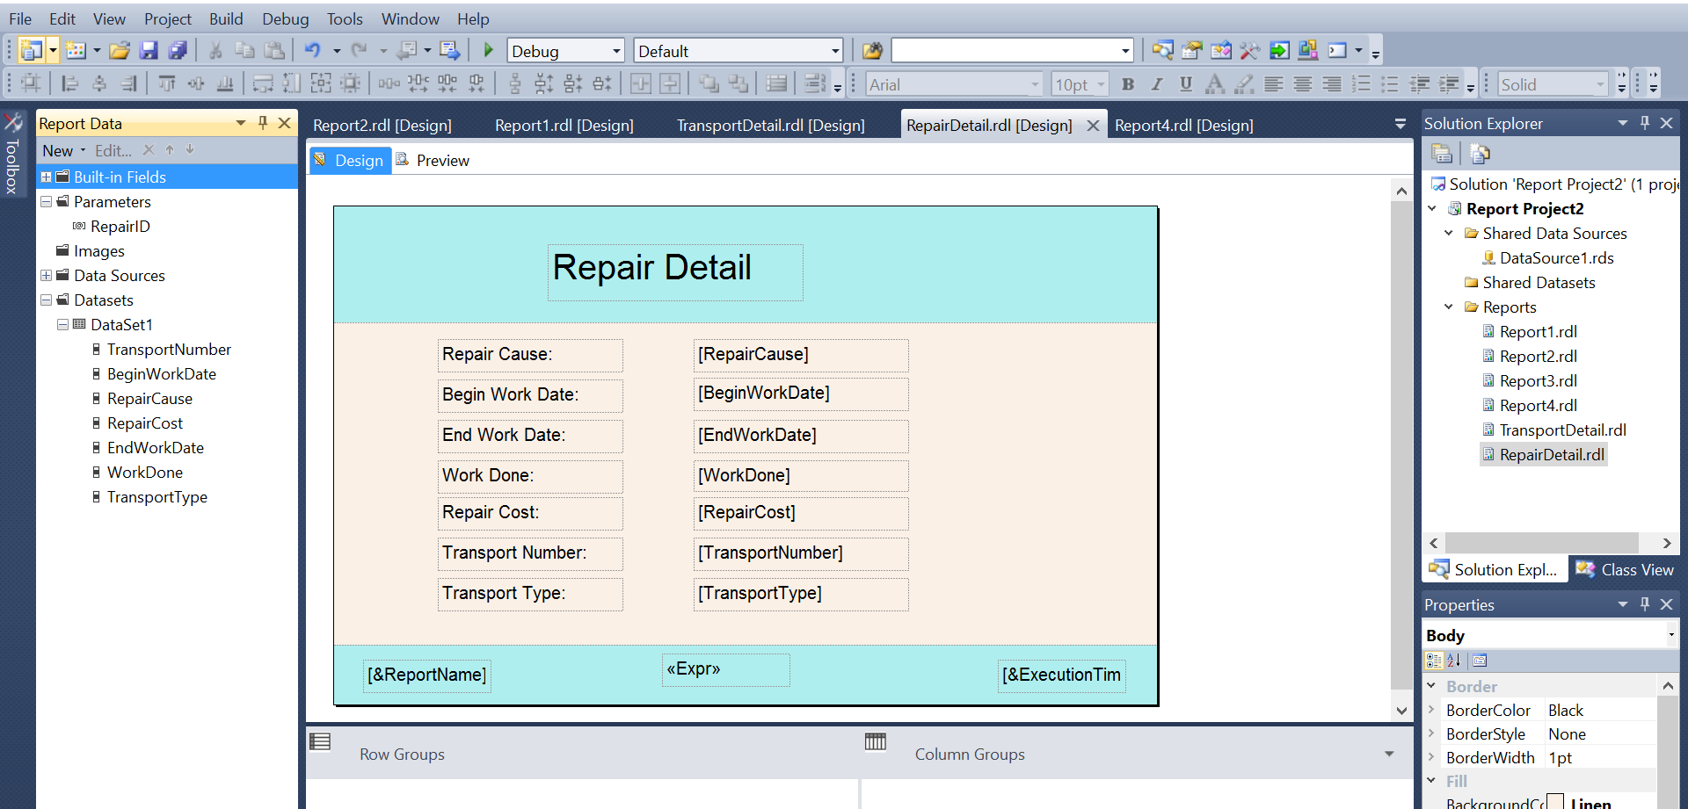

* 1. Connect to child report

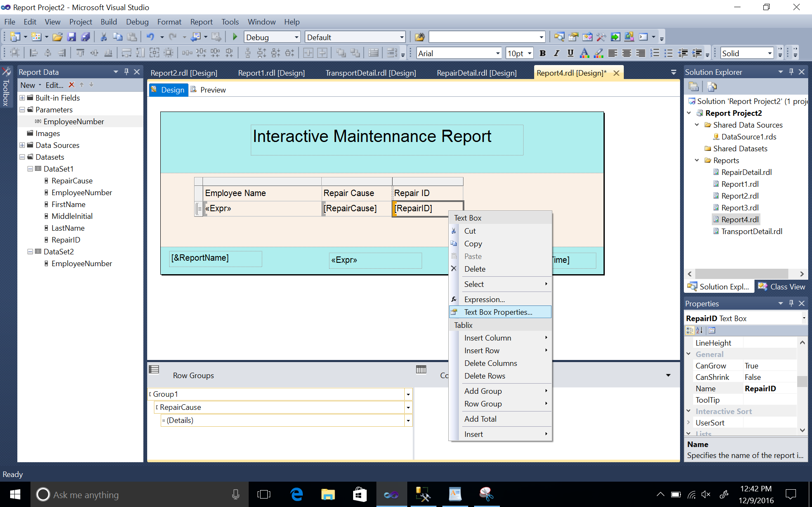

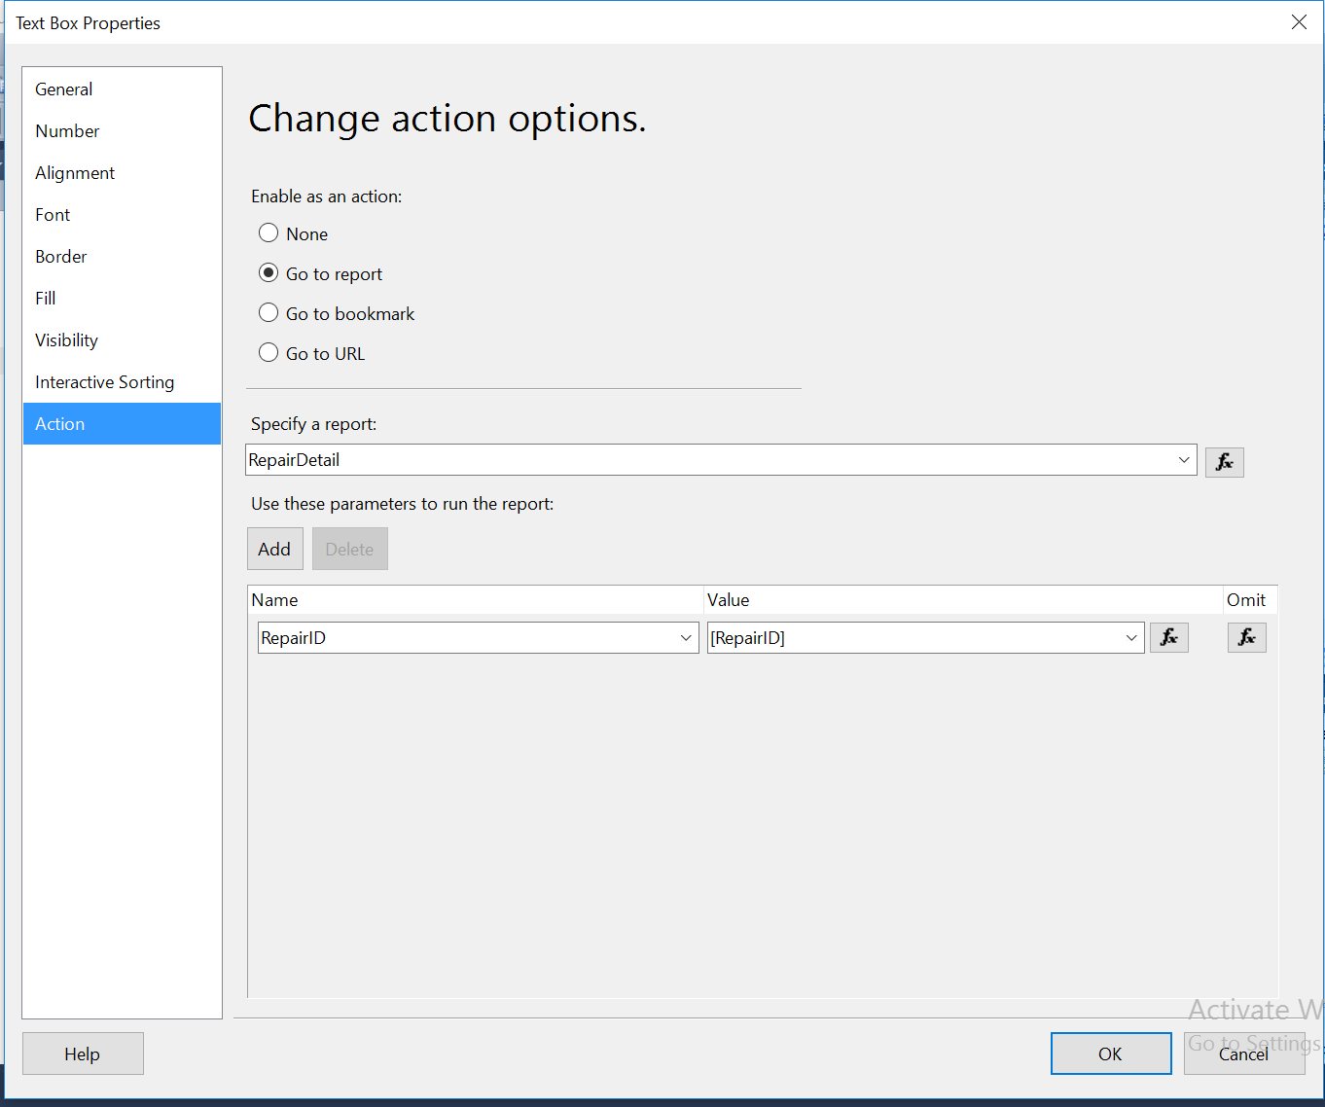

* 1. Show repair detail when repairID is clicked

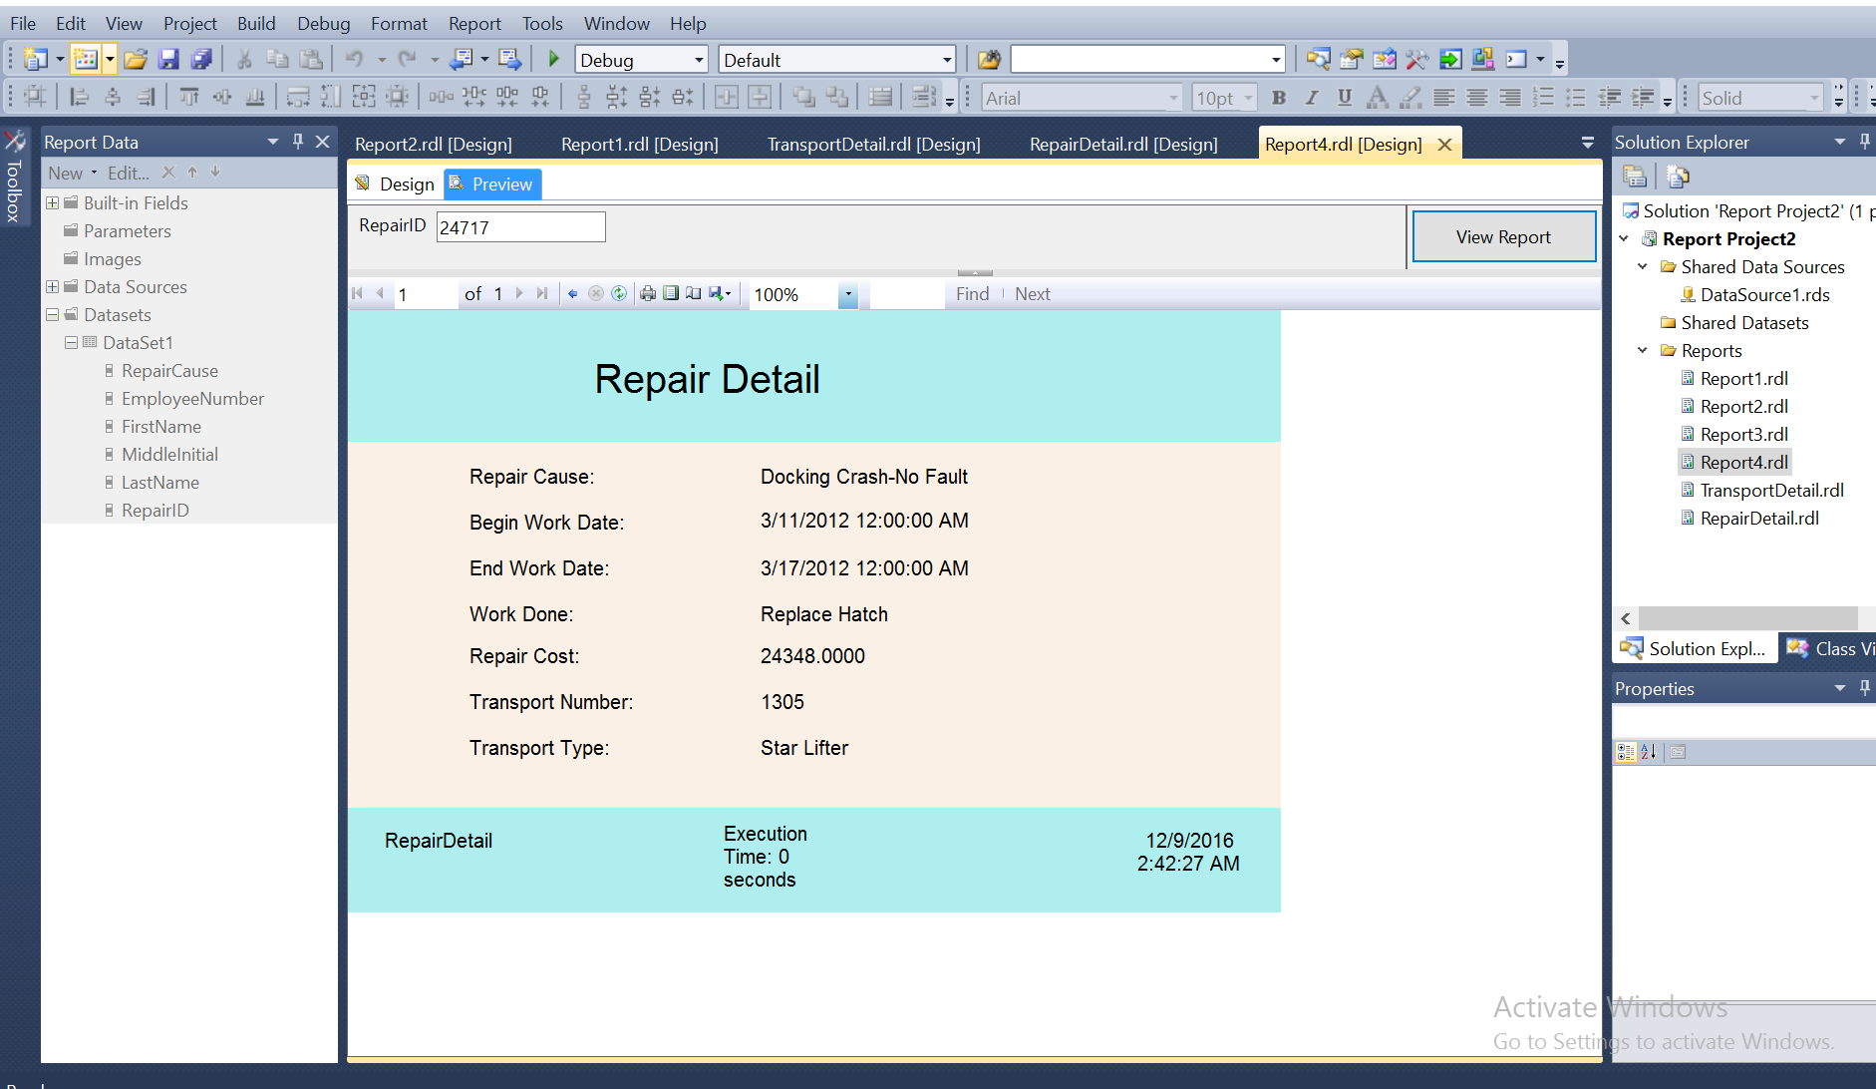

# Executing duration expression code

= "Execution Time: " +

IIf(System.DateTime.Now.Subtract(Globals!ExecutionTime).TotalSeconds < 1, "0 seconds",

(

IIf(System.DateTime.Now.Subtract(Globals!ExecutionTime).Hours > 0, System.DateTime.Now.Subtract(Globals!ExecutionTime).Hours & " hour(s), ", "") +

IIf(System.DateTime.Now.Subtract(Globals!ExecutionTime).Minutes > 0, System.DateTime.Now.Subtract(Globals!ExecutionTime).Minutes & " minute(s), ", "") +

IIf(System.DateTime.Now.Subtract(Globals!ExecutionTime).Seconds > 0, System.DateTime.Now.Subtract(Globals!ExecutionTime).Seconds & " second(s)", ""))

)

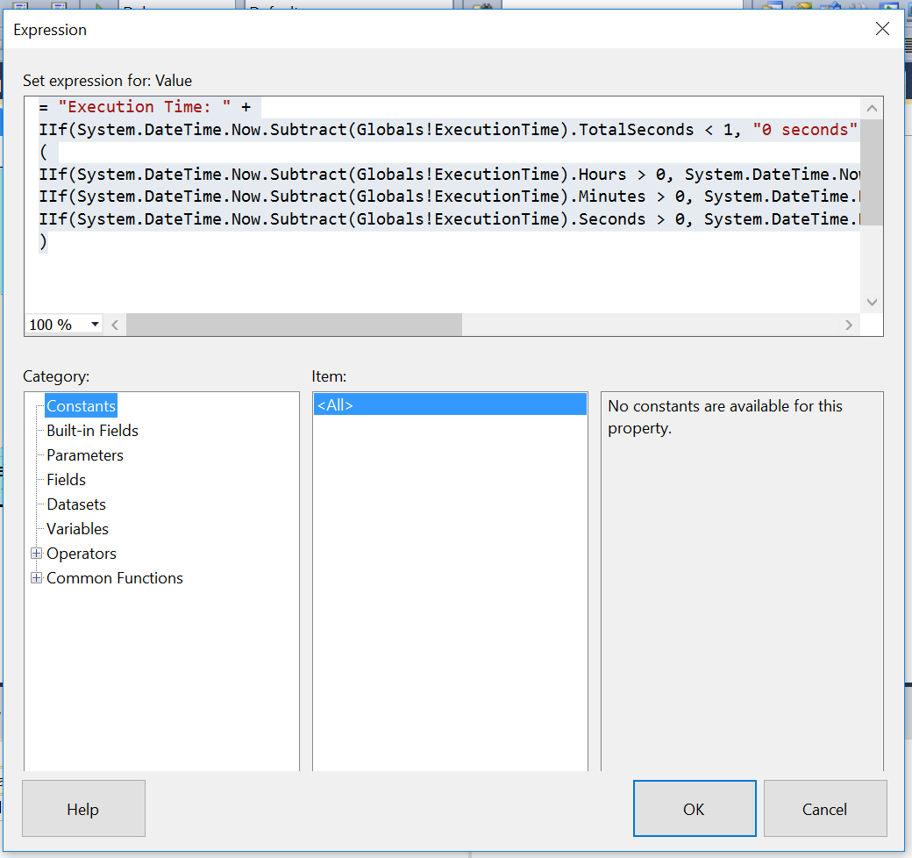

This expression code is included in the middle of the footer of every report.